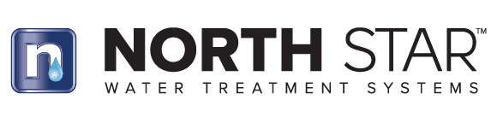

Bulletin No.: Date: Subject:
06202022
June 20, 2022
Product Obsolescence - 7337018
NSAS 2500 – 10” Standard Scale Management System

In an effort to simplify our product line offering effective immediately we have made obsolete the NSAS 2500 10” Standard Scale Management System part number 7337018. The replacement filters p/n 7337131 are available in limited quantities. The NSAS 4500 10” and NSAS 6500 Large Scale Management Systems are still available for those customers seeking a salt-free scale management solution for their home.

