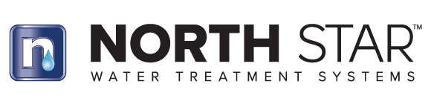

Bulletin No.: Date: Subject:

111422

November 11, 2022

**Product Obsolescence**

In an effort to improve our operational efficiency and streamline our product portfolio we will be discontinuing several low volume scale management systems from our offering. The following products are being discontinued as soon as existing inventory is depleted. We will continue to offer the EPAWCS8 as an anti-scale solution.

